

**Santos, Jacob S. Engr. Elizier L. Obamos**

**BSCpE – 4th Year Seminars and Fieldtrips**

1. **Project Name / Event: *128th PA Founding Anniversary: Cyber Defense Exercise (TRON 2025)***

**Day 1:** Cyber Ex-System Orientation | Introduction to Cybersecurity

**Day 2:** Introduction to Linux | Open-Source Intelligence (OSINT)

**Day 3:** Introduction to Forensics | Malware Forensics

**Day 4:** Anti-Forensics

**Day 5:** Introduction to VAPT | Vulnerability Analysis | Cyber Ex-System Walkthrough

**Day 6:** Cyber Exercise Proper

**Day 7:** Cont. Cyber Exercise Proper

1. **Period / Date:**

* **Day 1:** March 3, 2025 | 8:00 PM – 9:00 PM
* **Day 2:** March 4, 2025 | 8:00 PM – 9:00 PM
* **Day 3:** March 5, 2025 | 8:00 PM – 9:00 PM
* **Day 4:** March 6, 2025 | 8:00 PM – 9:00 PM
* **Day 5:** March 7, 2025 | 8:00 PM – 9:00 PM
* **Day 6:** March 8, 2025 | 7:00 AM – 8:00 PM
* **Day 7:** March 9, 2025 | 8:00 AM – 4:00 PM

1. **Project Objectives:**

The 128th Philippine Army Founding Anniversary: Cyber Defense Exercise (TRON 2025) aimed to foster cybersecurity awareness and readiness among academic institutions by simulating real-world cyber defense scenarios in collaboration with the Philippine Army. As a participant representing Emilio Aguinaldo College (EAC), the primary objective of the engagement was to develop critical skills in cyber forensics, ethical hacking, vulnerability analysis, and digital investigation through immersive learning and hands-on activities.

The initiative supported the strategic vision of “Army 2040: World-Class, Multi-Mission Ready, Cross-Domain Capable,” by preparing future defenders of the nation in the cyber domain. The event was structured into two comprehensive phases.

Phase 1, conducted from March 3 to March 7, 2025, consisted of daily online lectures via video teleconferencing. These lectures focused on essential topics such as Introduction to Linux and Open-Source Intelligence (Day 1), Computer Forensics and the Investigation Process including Network Forensics (Day 2), Malware Forensics (Day 3), Reconnaissance and Enumeration, Network Mapping, and Web App Scanning (Day 4), and finally, Vulnerability Analysis, Website Hacking, and a Cyber Exercise System Walkthrough (Day 5). These preparatory sessions equipped participants with the necessary theoretical knowledge and practical insights to handle real-time cyber threats.

Phase 2, the Exercise Proper, took place at Ricarte Hall, Philippine Army Officer Clubhouse, Fort Bonifacio, Taguig City. On March 8, 2025 (Day 6), the event commenced with registration at 7:00 AM followed by the Opening Ceremony, which included prayers, welcome remarks, and a keynote message from high-ranking Army officials including COL Windell Frederick T. Rebong and BGEN Jamel P. Samonte. The cyber exercise was then formally launched by the directorate, signaling the start of live competition.

On March 9, 2025 (Day 7), the Cyber Exercise Proper continued from 8:00 AM to 4:00 PM, followed by a 5:00 PM awarding ceremony recognizing outstanding participants and teams. The event concluded with closing messages from COL Rebong and LTGEN Roy M. Galido, the Commanding General of the Philippine Army.

Overall, this comprehensive week-long program not only highlighted the Army’s commitment to modern warfare preparedness but also provided a platform for students like those from EAC to contribute their technical expertise toward national cybersecurity resilience.

1. **Members**

**Day 1: Instructors -** CPT Venice Mae V Corpuz (SC) PA, PFC Kristina Ana O Tamayo (Inf) PA

**Day 2:** **Instructors -** PFC Jamil Krysthan L Beset (Inf) PA, Pvt Roy Dan Saludo (Inf) PA

**Day 3: Instructors -** Pvt Kristopper D Alsol (Inf) PA, PFC Ryan N Escalera (Inf) PA

**Day 4: Instructors -** PFC Ryan N Escalera (Inf) PA

**Day 5: Instructors -** PFC John Mark J Alfonso (Inf) PA, PFC Win T Corvera (Inf) PA

**Day 6:**

* **COL Windell Frederick T. Rebong, MNSA (SC) PA**

*Assistant Chief of Staff for C4S, G6, PA*

* **BGEN Jamel P. Samonte, PA**

*Commander, Army Signal Regiment (ASR)*

**Day 7:**

* **COL Windell Frederick T. Rebong, MNSA (SC) PA**

Introduced the Guest of Honor and Speaker (GOHAS) during the closing ceremony

* **LTGEN Roy M. Galido, PA**

*Commanding General, Philippine Army*

* **G6, PA and Commander, ASR**

Led the awarding of plaques and certificates to winners and participants

1. **Implemented Program Components**

**Day 1 – Cyber Ex-System Orientation & Introduction to Cybersecurity**

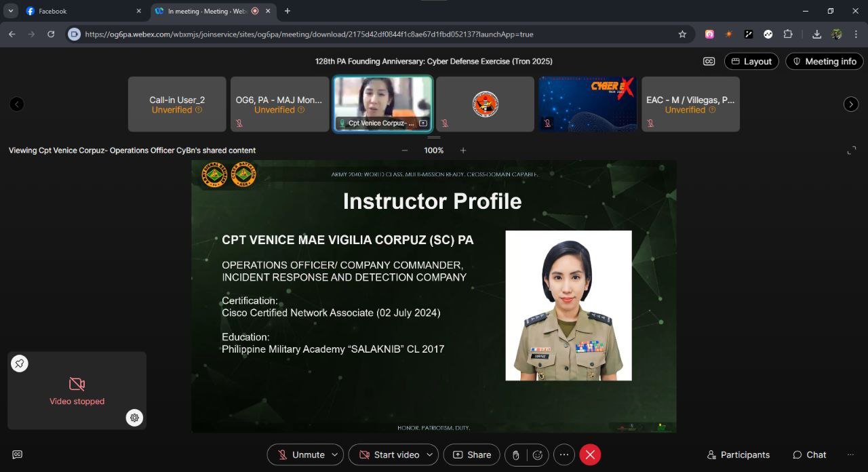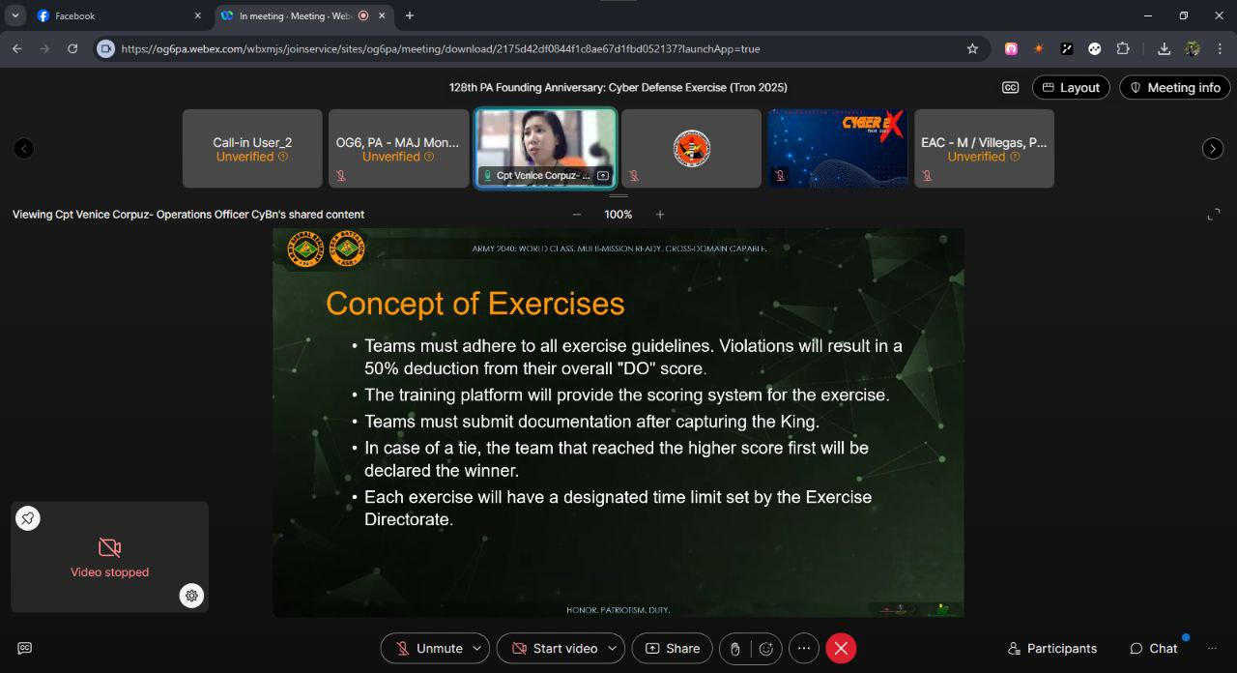

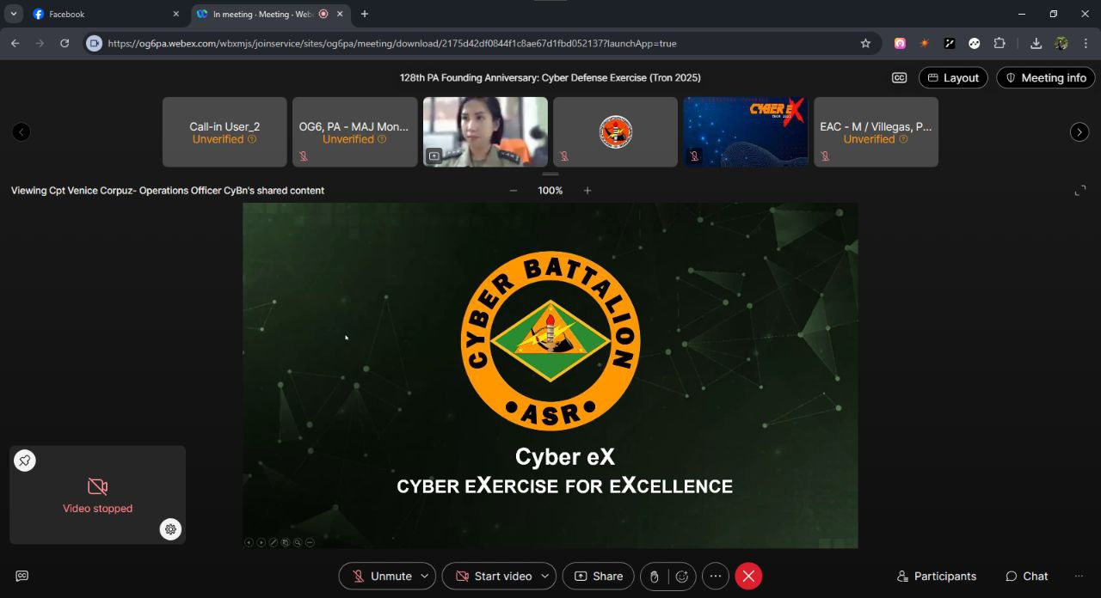

The Cyber-Ex Online Lecture officially began on March 3, 2025, with an introductory session titled Cyber Ex-System Orientation, conducted by CPT Venice Mae V. Corpuz (SC) PA. This session laid the groundwork for the week-long training by familiarizing participants with the structure, objectives, and tools to be used in the cyber exercise. Most notably, CPT Corpuz discussed the official guidelines for the upcoming Cyber Exercise competition, providing a clear framework for scoring, team coordination, technical expectations, and compliance with ethical standards. These guidelines ensured that all participants had a unified understanding of how the competition would proceed.

In the second session of the evening, PFC Kristina Ana O. Tamayo (Inf) PA introduced the core principles of Cybersecurity, including the CIA triad (Confidentiality, Integrity, Availability), types of cyber threats, and defensive strategies. The lecture emphasized the importance of securing digital assets and highlighted current global trends in cybersecurity threats. These foundational topics were vital for participants to grasp before diving into more technical subjects in the following days.

**Day 2 – Introduction to Linux & Open-Source Intelligence (OSINT)**

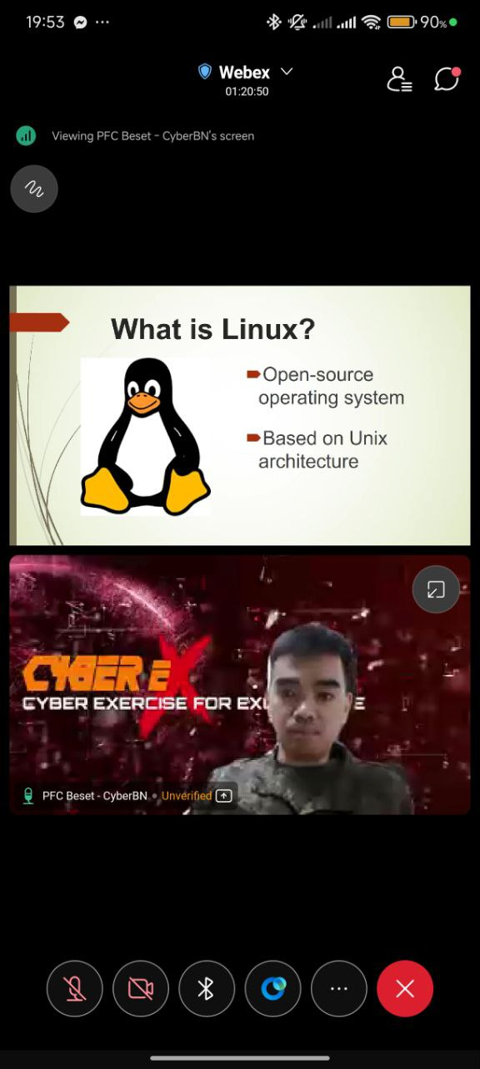 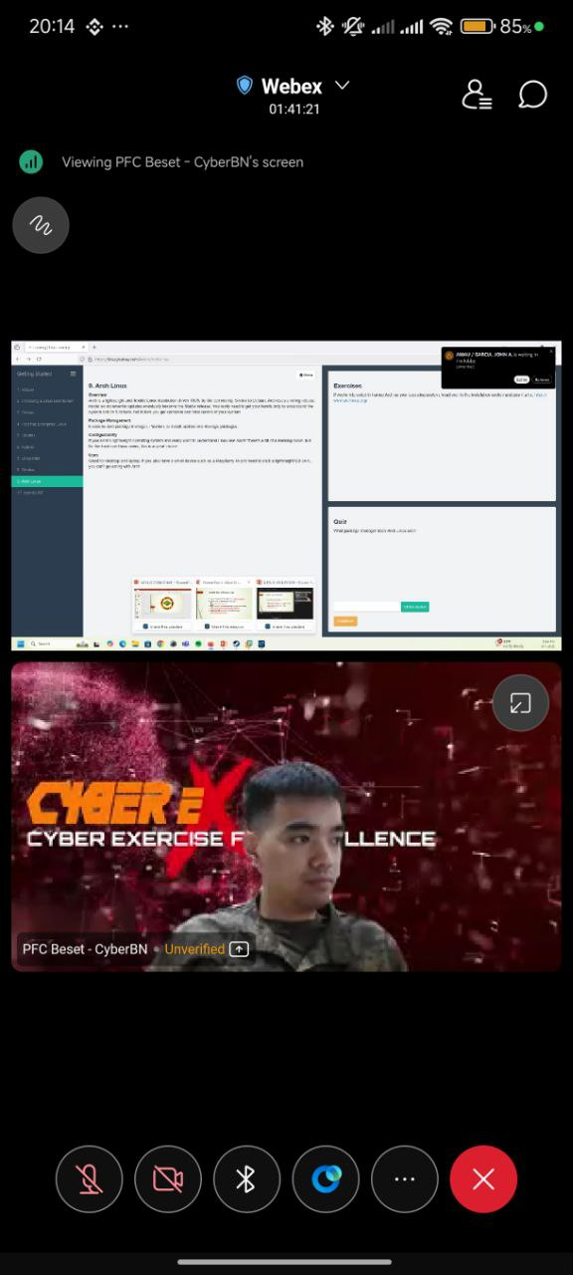

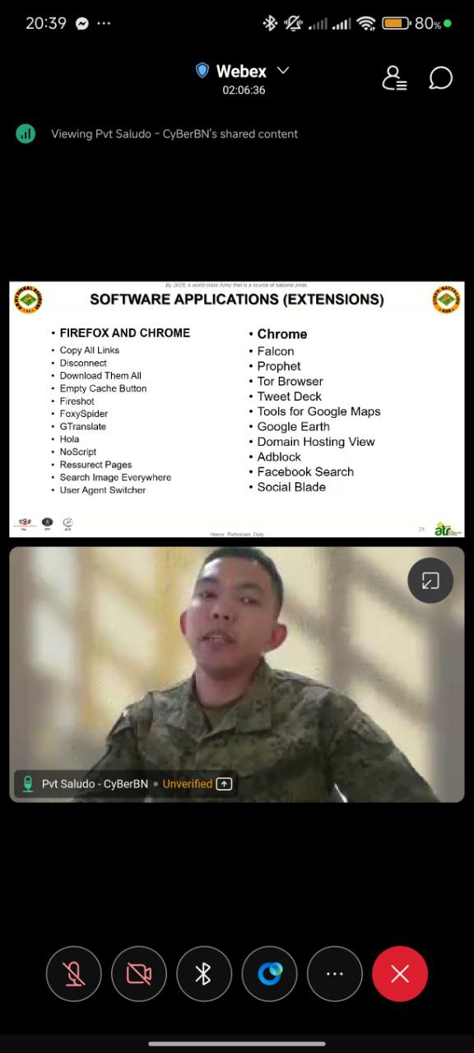 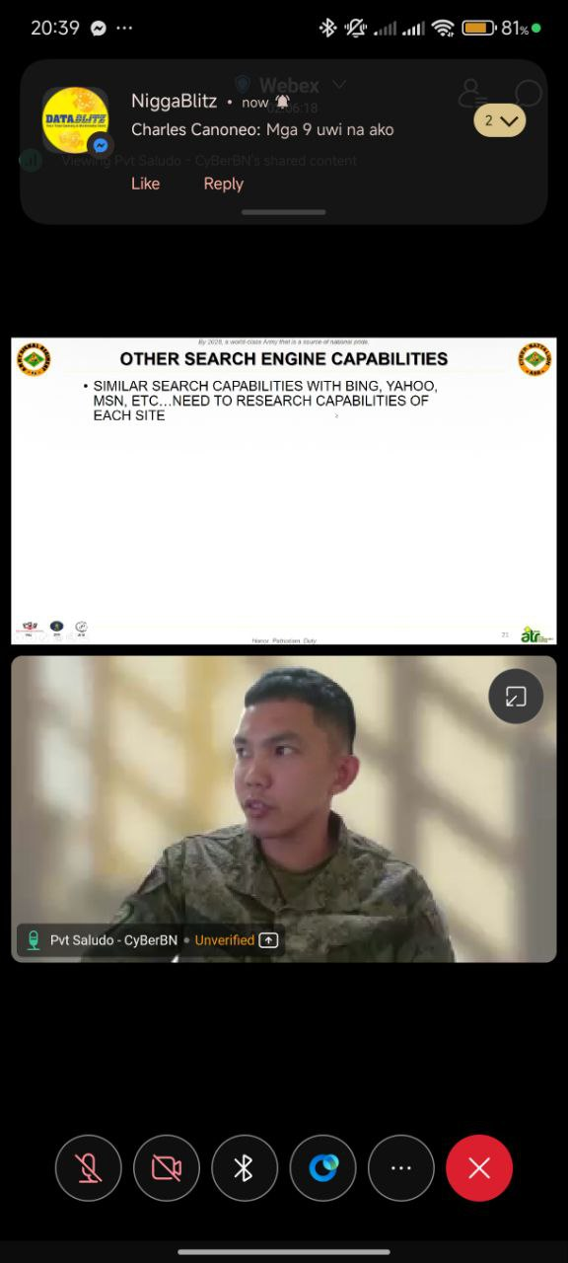

The second day of the lecture series, held on March 4, 2025, turned the spotlight on essential tools and techniques widely used in cybersecurity operations. The first lecture, Introduction to Linux, was facilitated by PFC Jamil Krysthan L. Beset (Inf) PA. The session offered participants hands-on exposure to Linux operating systems, particularly command-line operations, user account management, and file permissions. PFC Beset emphasized Linux's dominance in cybersecurity infrastructures, particularly due to its flexibility, transparency, and widespread use in penetration testing and server environments.

The second session focused on Open-Source Intelligence (OSINT), presented by Pvt Roy Dan Saludro (Inf) PA. This lecture explored how information publicly available on the internet can be gathered and analyzed for cybersecurity purposes. Tools and techniques used in OSINT, such as advanced Google searching, metadata analysis, and social media scraping, were demonstrated. Pvt Saludro underscored the ethical and legal implications of OSINT while showcasing how threat actors and security professionals alike use open data for both attack and defense.

**Day 3 – Introduction to Forensics & Malware Forensics**

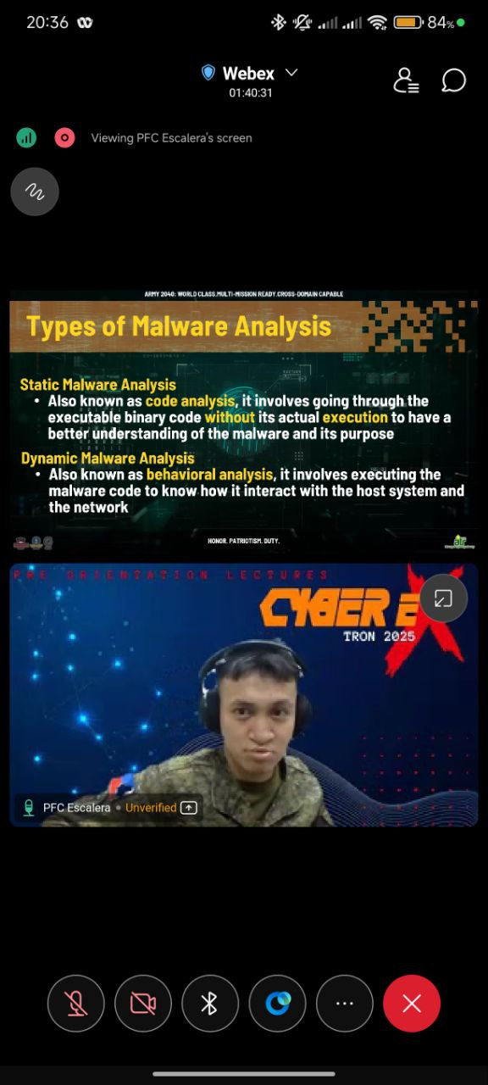 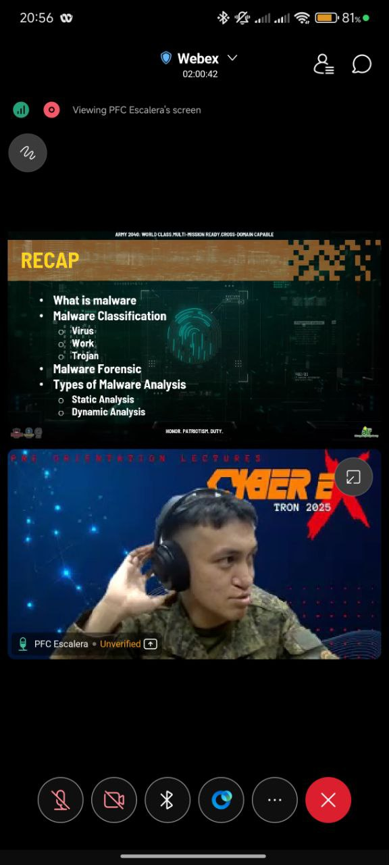

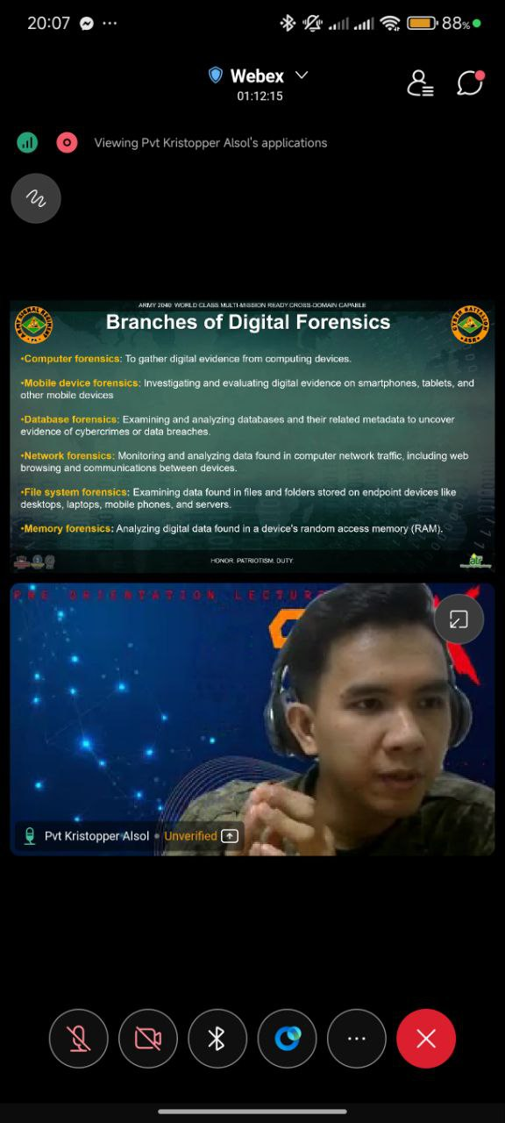 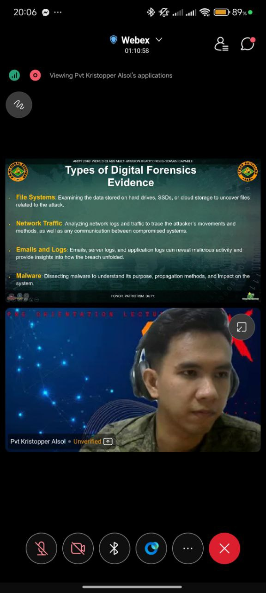

On March 5, 2025, the focus shifted toward Digital Forensics, an essential component in the investigation of cyber incidents. Pvt Kristopper D. Alsof (Inf) PA opened the session with an Introduction to Forensics, where he explained the processes of identifying, preserving, analyzing, and presenting digital evidence. The discussion included file recovery, data integrity validation, and the importance of maintaining a strict chain of custody during investigations.

The evening continued with Malware Forensics, taught by PFC Ryan N. Escalera (Inf) PA. This session drilled into the techniques used to reverse-engineer malware and identify its origins and behavior. Participants learned about malware types such as ransomware, trojans, and spyware, as well as the tools used to detect and dissect them. By understanding how malware operates, participants were better equipped to formulate defensive strategies and trace cyberattacks back to their sources.

**Day 4 – Anti-Forensics**

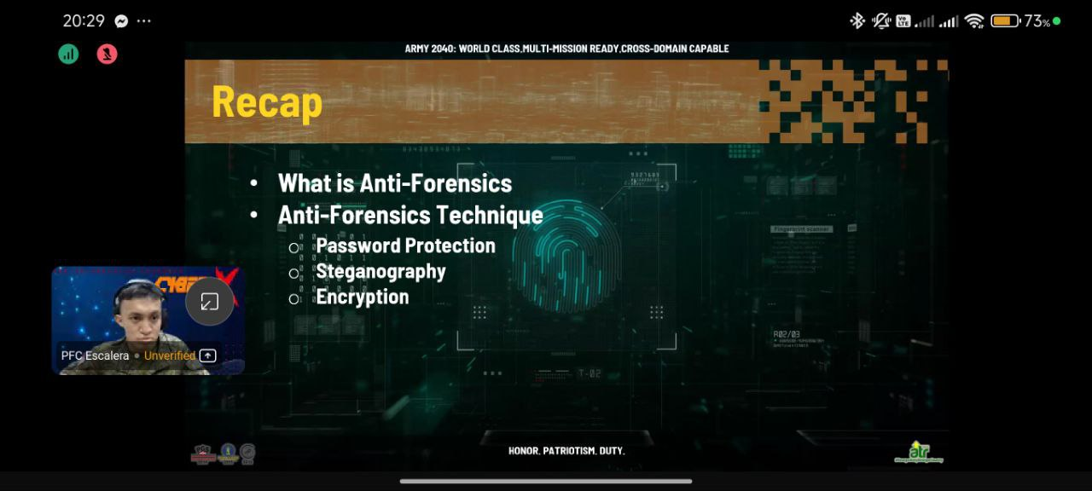

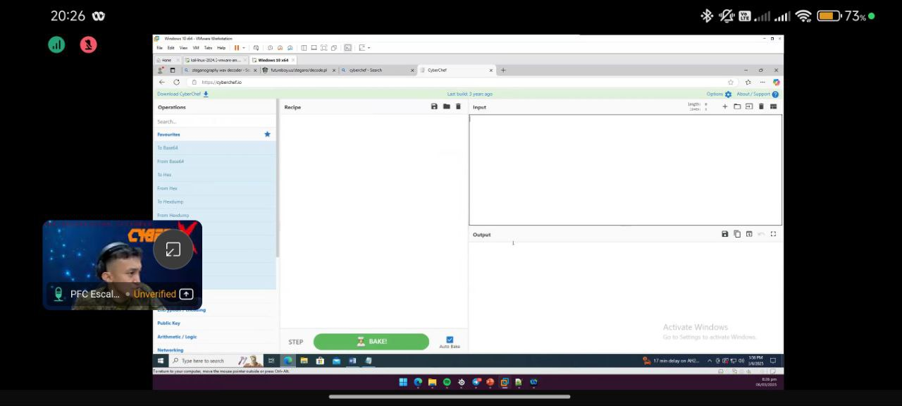 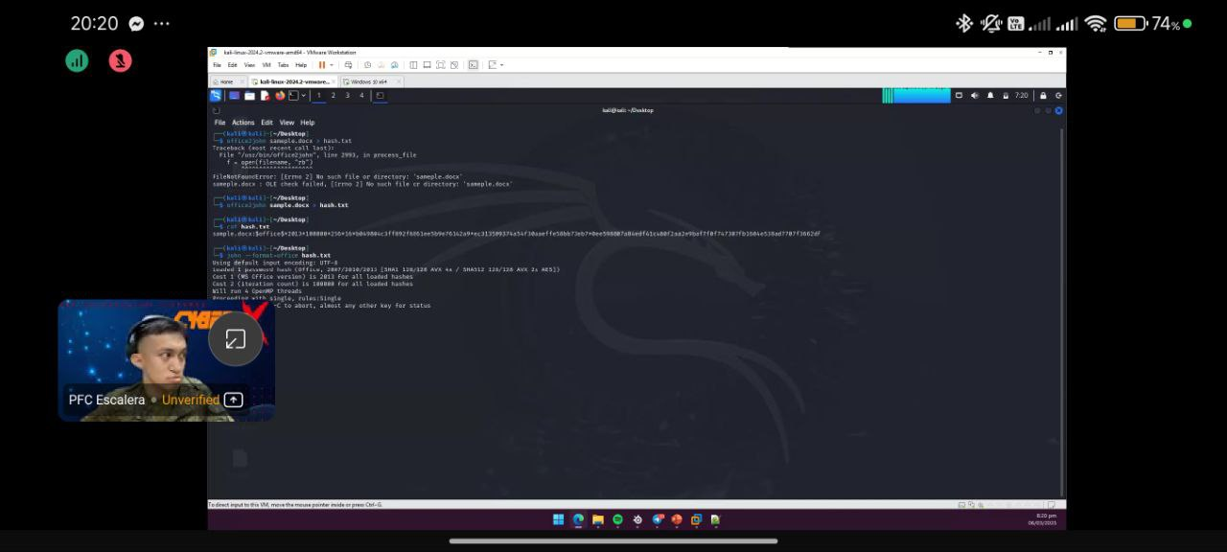

March 6, 2025, was devoted entirely to the study of Anti-Forensics, a counter-discipline that involves strategies used by threat actors to evade detection and hinder investigations. PFC Ryan N. Escalera (Inf) PA returned to lead this session, covering techniques such as data wiping, encryption, steganography, metadata alteration, and time-stamping manipulation.

This lecture emphasized the constant cat-and-mouse dynamic between forensic analysts and attackers. By studying anti-forensics, participants gained insight into the tactics used by adversaries to delay or mislead investigations—knowledge that will be especially useful during the actual Cyber Exercise, where real-time analysis and response will be required.

**Day 5 – Introduction to VAPT, Vulnerability Analysis, & Cyber Ex-System Walkthrough**

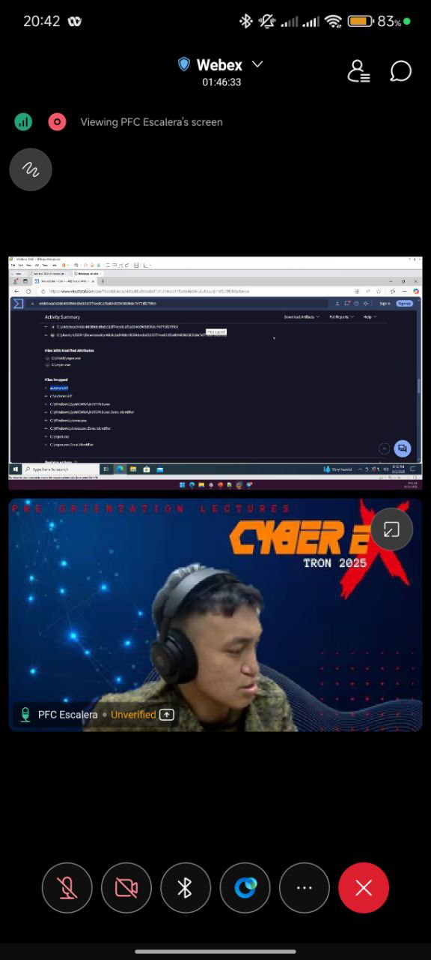 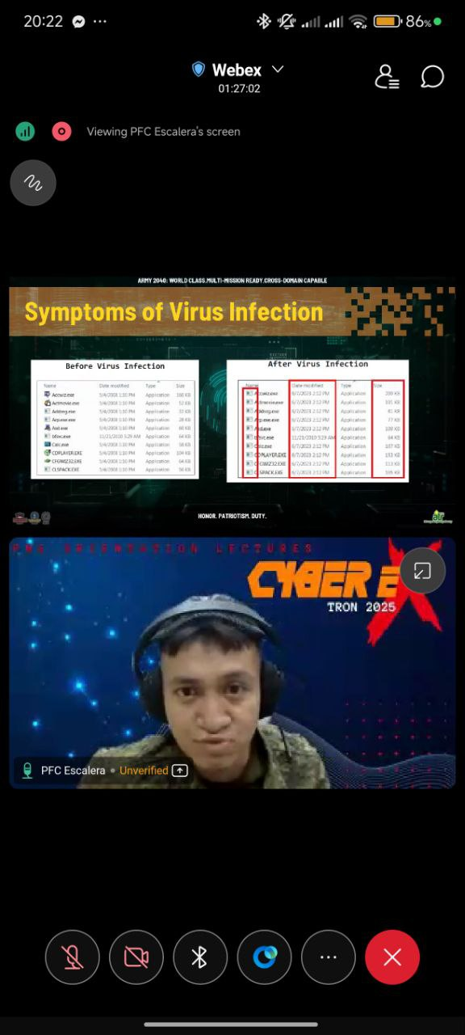

The fifth day of the Cyber-Ex Online Lecture, conducted on March 7, 2025, was densely packed with three technical sessions. PFC John Mark J. Alfonso (Inf) PA began with a detailed introduction to Vulnerability Assessment and Penetration Testing (VAPT). This lecture introduced methodologies used to identify vulnerabilities in systems and exploit them in a controlled environment to assess their impact. Participants were guided through various testing phases including reconnaissance, scanning, exploitation, and reporting.

Following this, a session on Vulnerability Analysis provided deeper insight into the lifecycle of security weaknesses—from discovery to remediation. Participants learned about CVEs (Common Vulnerabilities and Exposures), patch management, and automated vulnerability scanning tools. This session reinforced the importance of proactive defense and regular system auditing.

The day concluded with a Cyber Ex-System Walkthrough led by PFC Win T. Corvera (Inf) PA. This critical session served as a practical orientation for the upcoming competition, allowing participants to familiarize themselves with the actual system interface, scoring mechanics, and operational features of the simulated environment. This hands-on preview helped solidify the theoretical knowledge acquired throughout the week and ensured the teams were well-prepared for the weekend's exercise.

**Days 6–7 – Cyber Exercise (Capture-the-Flag Challenge)**

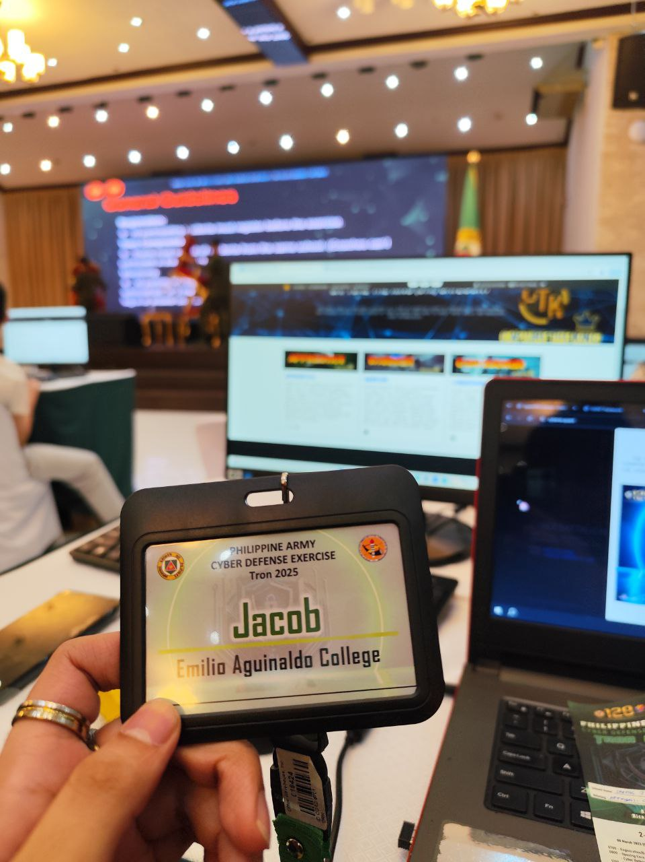 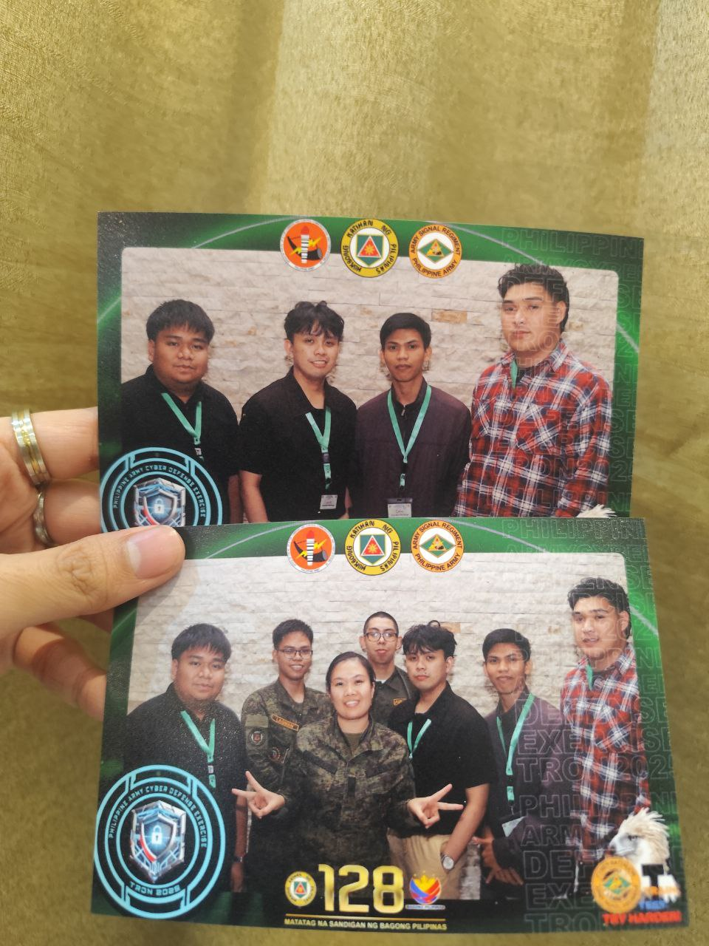

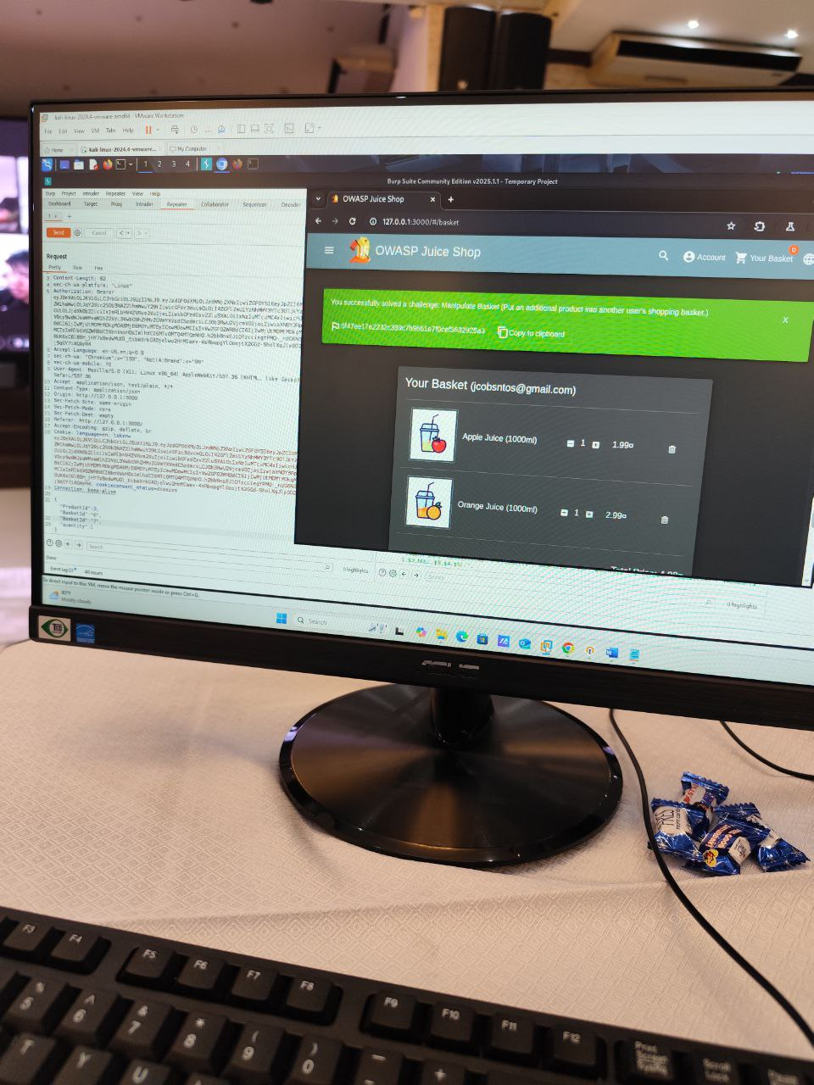

The Cyber Exercise proper officially commenced on March 8–9, 2025, marking Days 6 and 7 of the event. Over the course of these two days, participating schools and institutions engaged in a simulated cyber warfare environment through a Capture-the-Flag (CTF) competition hosted on the Cyber Ex-System. Teams were tasked with solving a variety of challenges designed to replicate real-world cyber incidents and scenarios, encompassing key areas such as Linux command-line operations, digital forensics, OSINT, malware analysis, vulnerability exploitation, and anti-forensics.

On the first day of the exercise (Day 6), teams began strategizing and tackling the easier and mid-level flags to build momentum. They were required to demonstrate effective coordination, quick problem-solving, and technical competency, all while racing against time. Real-time scoring kept the atmosphere intense, and participants had to balance between aggressive pursuit of points and careful system navigation to avoid penalties.

By Day 7, the final stretch of the competition, the pressure escalated. Teams focused on completing remaining challenges and maximizing their points. Advanced tasks pushed participants to apply all the knowledge they had acquired throughout the week—from identifying malware signatures to tracing obfuscated data and analyzing digital traces left by attackers. The complexity of the final round demanded peak performance, strong teamwork, and strategic execution.

Across both days, the competition tested not only technical proficiency but also adaptability, patience, and cyber discipline. All teams demonstrated professionalism and ethical conduct throughout the exercise. The simulation succeeded in mirroring real-time cyber threats, offering participants an invaluable experience in a safe, competitive environment. This culminating activity served as a testament to the participants’ growth and readiness to contribute to the country’s cyber defense objectives.

**Awarding Ceremony**

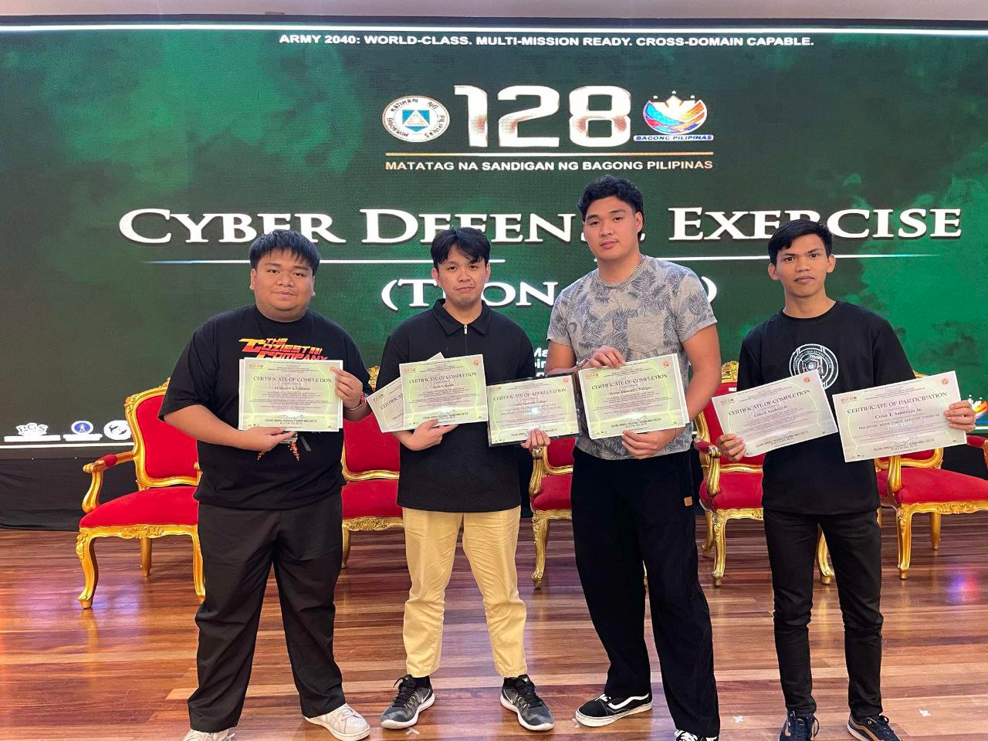

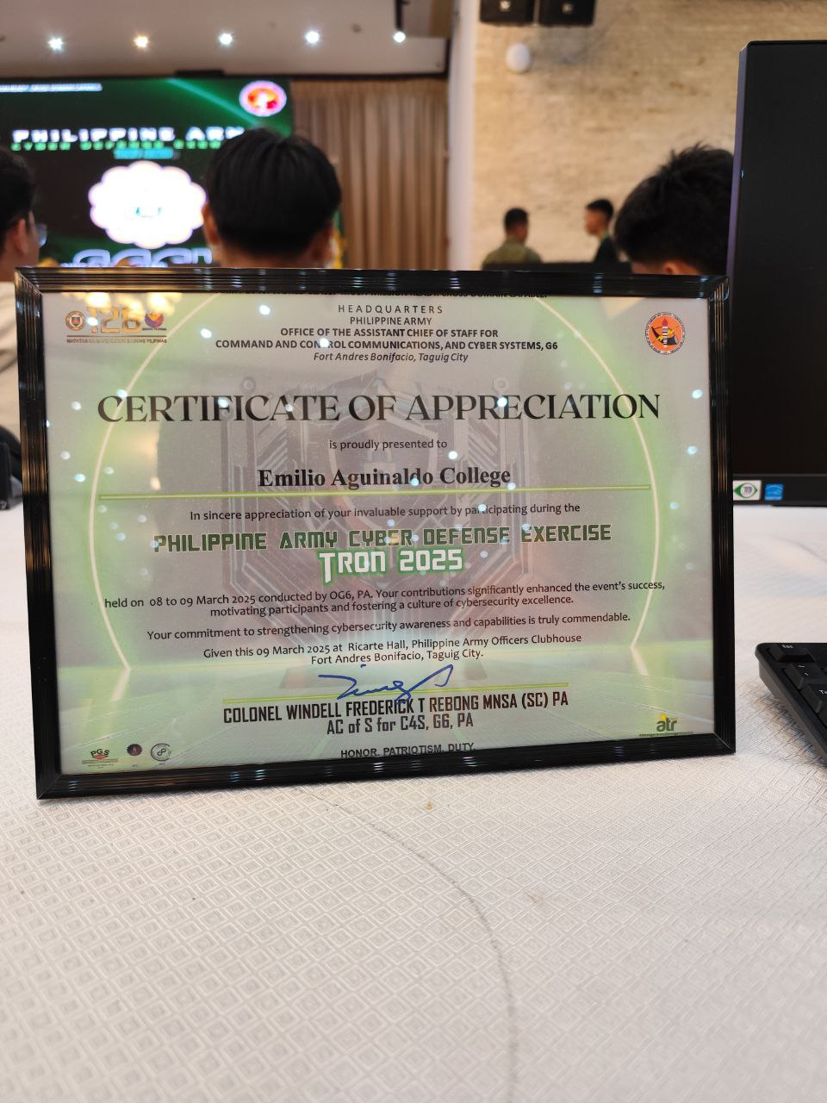

The culmination of the week-long event was the Awarding Ceremony, where the results of the Cyber Defense Exercise were officially announced. Participating teams were recognized for their performance, efforts, and contributions to the overall success of the program. The representatives of Emilio Aguinaldo College (EAC) proudly secured 9th place overall in the final CTF rankings, reflecting their determination, teamwork, and technical growth.

In addition to this, Team EAC earned distinction by winning one of the Ice Breaker rounds, showcasing their agility and competitiveness early in the exercise. The moment was met with applause and highlighted the team’s active participation and potential in cybersecurity operations. The ceremony celebrated not just rankings, but also the collective commitment to national cybersecurity awareness and preparedness, uniting civilian academic institutions and military units under a common cause.

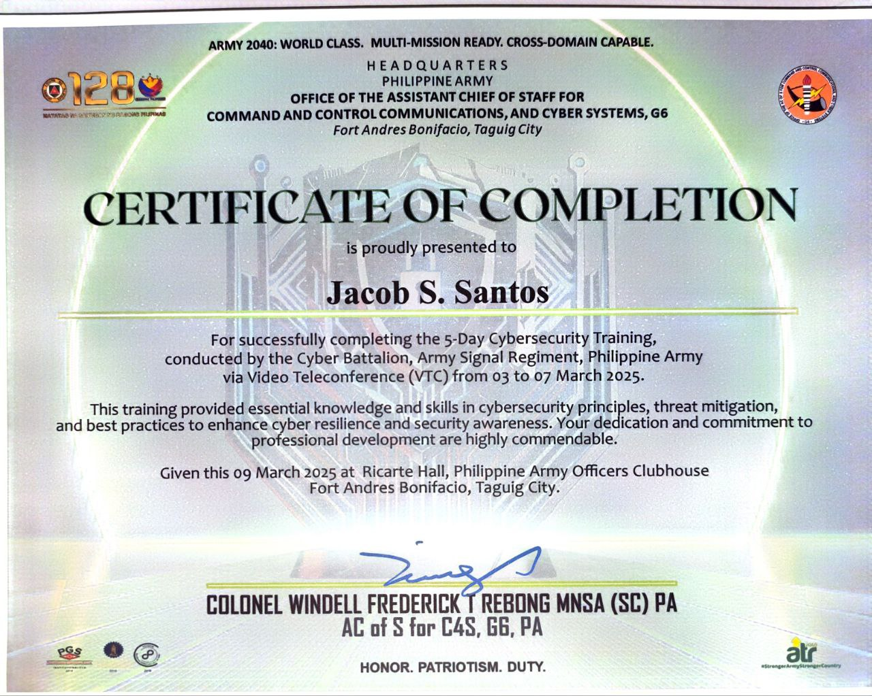



1. **Project Name / Event:** *DOST Educational Tour*
2. **Period / Date:** May 16, 2025 | 9:00 AM – 12:00NN
3. **Project Objectives:**

The primary objective of this educational plant tour to the DOST-Metals Industry Research and Development Center (DOST-MIRDC) was to provide Computer Engineering students from Emilio Aguinaldo College with an in-depth understanding of advanced manufacturing processes, particularly additive manufacturing. By visiting the Advanced Manufacturing Center (AMCen), students were given a unique opportunity to witness state-of-the-art technologies that are revolutionizing the manufacturing industry in the Philippines and around the world.

Another key objective of the visit was to expose students to real-world applications of computer engineering principles in the context of industrial automation, 3D printing, and product prototyping. The hands-on demonstrations and expert-led discussions allowed students to bridge the gap between classroom learning and industry practices, equipping them with practical knowledge and a clearer vision of career pathways in high-tech manufacturing sectors.

Furthermore, the tour aimed to inspire innovation and foster a deeper appreciation for local advancements in engineering technology. By observing DOST-MIRDC's contributions to national industrial development and technological self-reliance, students were encouraged to pursue projects and research that align with the goals of sustainable and future-ready manufacturing in the country.

1. **Members**
2. **Participating Students** – BSCpE 4th year
3. **Faculty Adviser** – Engr. Elizier L. Obamos
4. **Tour Facilitators from DOST-MIRDC**
5. **Implemented Program Components**

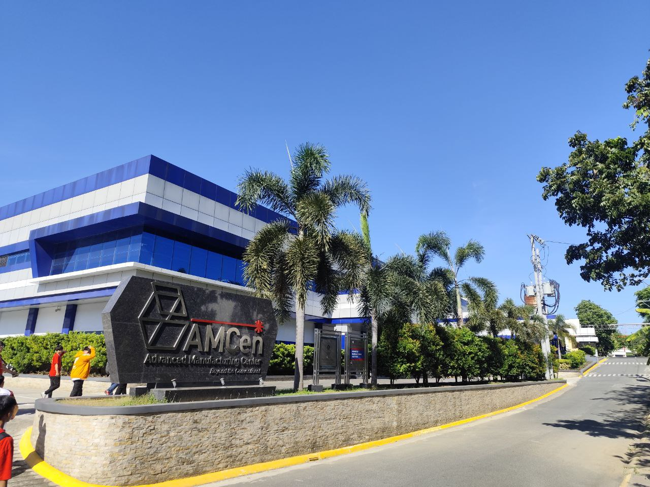 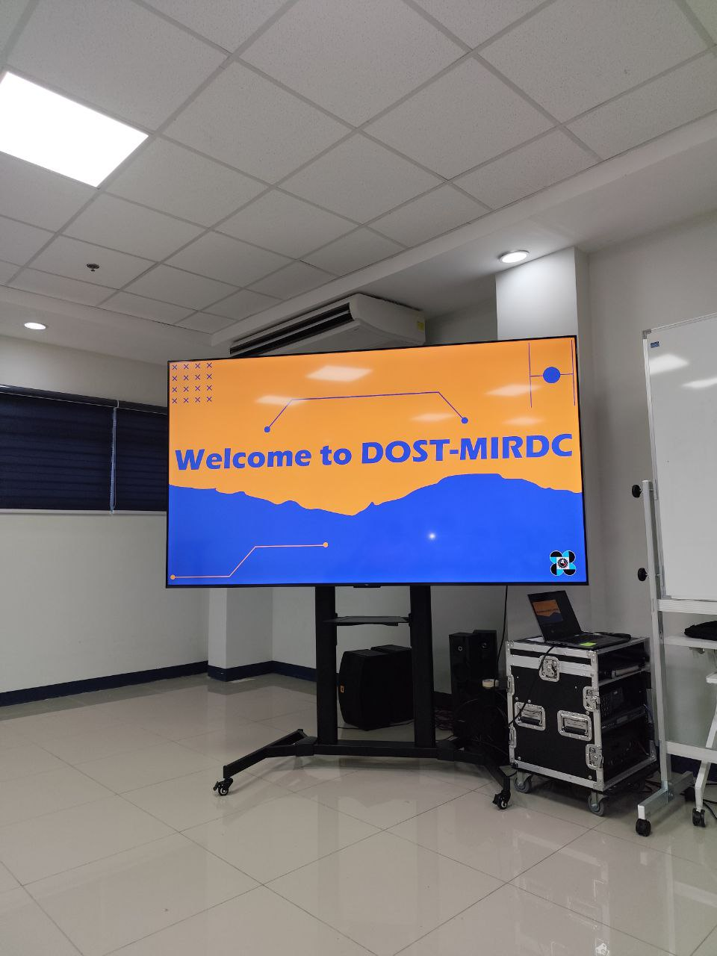

The plant tour began with an orientation session at the DOST-MIRDC headquarters where students were formally welcomed by the AMCen staff and introduced to the agency’s role in supporting the country’s metals and engineering industries. The orientation included a brief history of the DOST-MIRDC and its mission to promote innovation and technological advancement through its research, development, and specialized services.

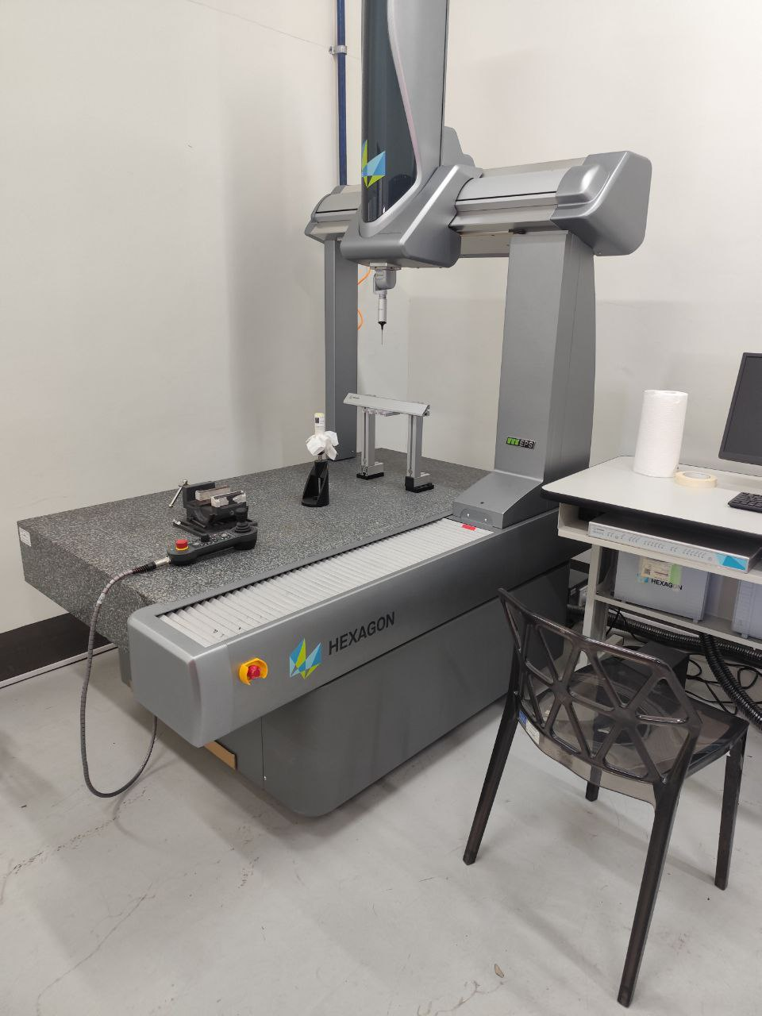 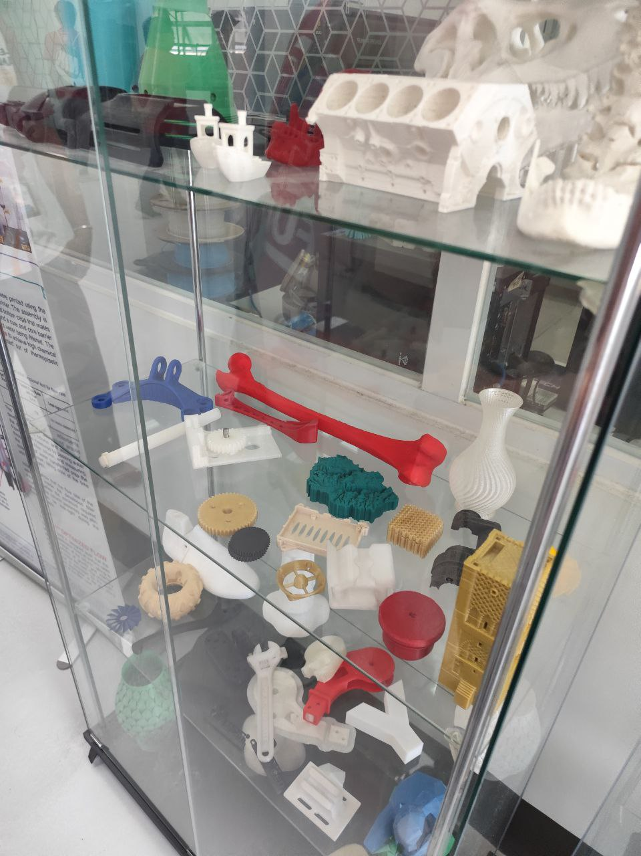

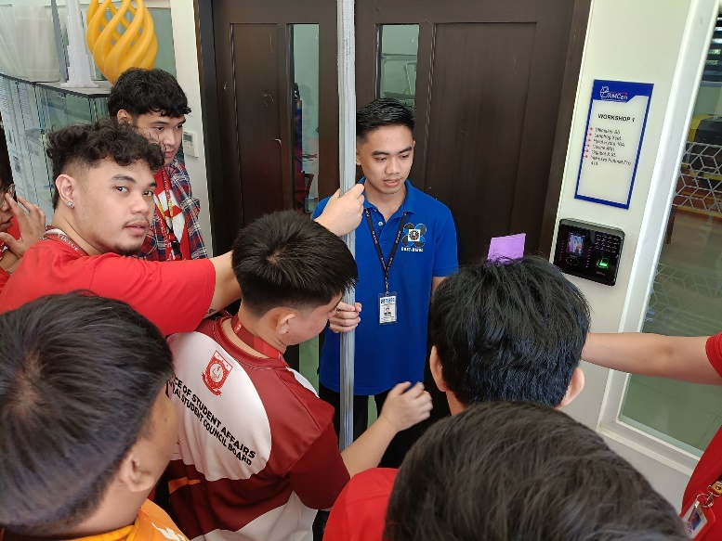

After the orientation, the group was led into the Advanced Manufacturing Center (AMCen), where the main focus was on additive manufacturing—commonly known as 3D printing. The facilitators explained that AMCen houses cutting-edge equipment capable of producing high-precision parts and prototypes using various 3D printing technologies. The facility aims to boost local manufacturing capabilities and support industries such as aerospace, automotive, electronics, and biomedical engineering.

Students were introduced to different 3D printing methods, including Fused Deposition Modeling (FDM), which uses thermoplastic materials to build objects layer by layer. The staff demonstrated how FDM printers operate, emphasizing their accessibility for prototyping and educational purposes. They also discussed material properties, common applications, and maintenance tips for this type of printer.

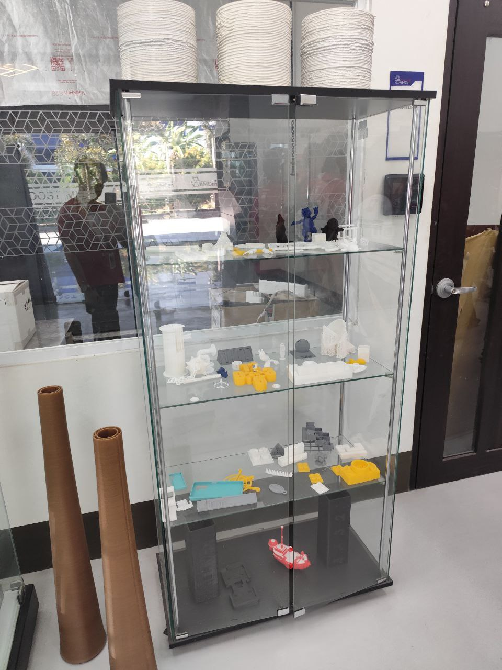 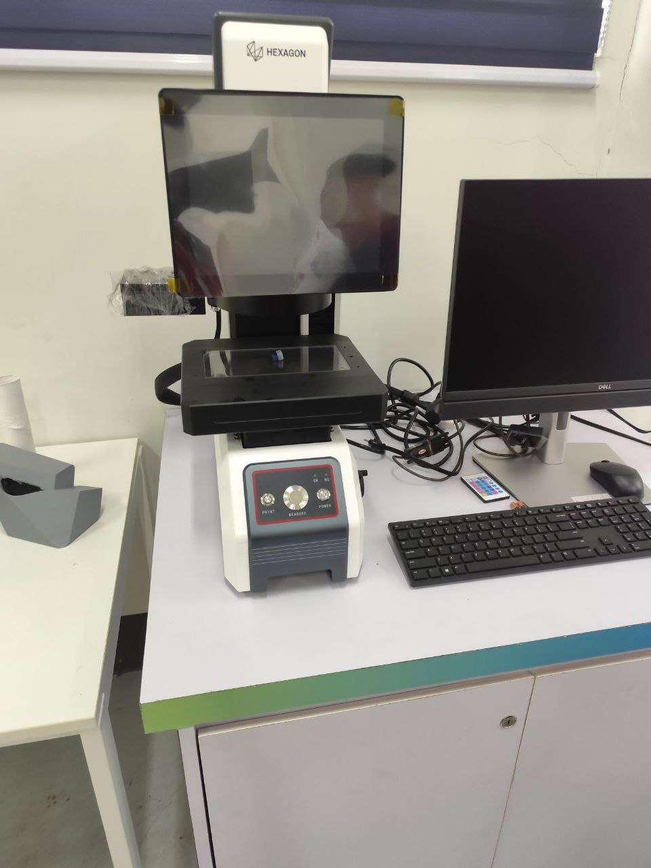

Another highlight was the Selective Laser Melting (SLM) and Direct Metal Laser Sintering (DMLS) technologies used in metal 3D printing. These advanced systems allow the production of complex metal parts with high strength and precision by using a laser to fuse fine metal powders. The facilitators explained how these technologies are used in the manufacturing of functional components for high-performance machinery and tools.

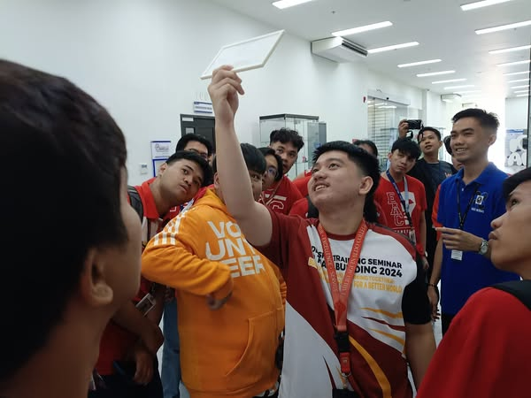

In addition, the tour included a demonstration of 3D scanning technology, which plays a crucial role in reverse engineering and quality inspection. Students observed how an object could be digitally captured using a scanner and then replicated or modified in CAD software before being printed. This workflow showed how additive manufacturing integrates with digital design and modeling.

The program concluded with a Q&A session where students engaged with the DOST-MIRDC engineers and researchers. Topics such as local industry collaboration, research opportunities, and future developments in advanced manufacturing were discussed. The visit provided students with a deeper understanding of how 3D printing is transforming the landscape of manufacturing and engineering, and how they, as future engineers, can contribute to this growing field.